Leader Overview
Volume Overview
Believe Boldly
The gospel message is shocking to many, shocking because of its implications. God has made himself known to us and promised to place His Spirit into our heart. We have been given direct access to Him. The Bible encourages us to come to Him with boldness. Our boldness in approaching Him is not from our words or our achievements. Instead, it’s based on God’s promises. So we ask, remembering His power and faithfulness. And we encourage those around us to do the same. Believe boldly.
Session Overview
Remember His Power
In this Live session, kids will discover that God has the power to do impossible things. When we better understand what God can do and how much He loves us, we can have greater faith in His care for us.
Bible Lesson
A Roman Officer Shows Impressive Faith
Matthew 8:5–13
Faith Fact
I can believe for the impossible.
Faith Verse
1 Corinthians 16:13–14 (NLT)
Be on guard. Stand firm in the faith. Be courageous. Be strong. And do everything with love.

Preparing for the Session
Leader Preparation Time: 20–25 Minutes
You Will Need
Large Group
- Bible
- Worship songs (Song suggestions: “Nothing Is Impossible” Lyric Video by Planetshakers; “10,000 Armies” by Influence Music; “Way Maker” Lyric Video by Leeland; “Do It Again” by Elevation Worship)
- For groups not using a phone or tablet only, add:
• Projector or TV
• Laptop
• Countdown60 Video–60 seconds
• Faith Fact Slide
• Faith Verse Video or Slide
• Bible Lesson Video
• Teaching Point Slides 1–3
- Bottle of water with about two inches of water in it
- Table or firm surface for the water bottle flip
- Ten apples
- Sandwich cookies
- Two rolls of toilet paper
Small Group
- Ball
- Bibles for kids in the group to share
- Small Group Faith Verse Review, one per team
- Scissors
- Small Group Activity Page, one per kid
- Small Group Activity Page Answer Page
- Pencils or pens, one per kid

To access session content and videos from a computer, visit: BibleEngagementProject.com/downloads

Getting Ready
Large Group
• Download videos and slides if needed.
• Select worship song(s) and have them ready to play.
• Read the Bible Lesson Scripture to prepare for Teaching Time.
• Optional: Watch this video for water bottle flip challenges.
Small Group
• Print copies of the Small Group Faith Verse Review, one per team.
• Cut apart the words of the Faith Verse for each team.
• Print copies of the Small Group Activity Page, one per kid.
• If needed, print a copy of the Small Group Activity Page Answer Page.

First time leading Live for Kids? Check out the Facilitator Guide.
Large Group
30 Minutes
See what’s needed at the beginning of the session.

Introduction
Hey, everybody! I’m so excited we’re together today. We’ve been learning how to believe boldly in who God is and what He does. What does it mean to be bold? (Allow responses.) I think it’s being courageous, unafraid, and loud about what you believe! But it’s not always easy to believe boldly that you or someone else can do what seems impossible.
• Hold up the water bottle.
Have you ever watched an amazing trick-shot video? (Group response) It’s really fun to see people do tricks that seem impossible! How many of you have ever tried to flip a water bottle so it lands standing up? (Group response) I’ll give it a try.
• Demonstrate the water bottle flip.
How did I do? (Group response) Here’s an even harder trick. Has anyone here ever flipped a water bottle so it landed on its top? (Group response) Some of you can try that during our Bible story today. These tricks can be so satisfying—when they actually work! But it can take a long time to get them just right, and sometimes they are absolutely impossible to repeat!
Faith Fact
Talking about impossible things reminds me of our Faith Fact for today: I can believe for the impossible. We’re not talking about impossible things we can do. Our Bible story is about someone who believed that God could do something impossible, and it happened!
• Show the Faith Fact Slide.

Sometimes it’s hard to believe that impossible things can happen. After all, the word impossible literally means that there’s zero chance of something happening. But with God, nothing is impossible. We can trust that He can do anything. Everyone, stand up boldly! (Group response) Good job! Now point to your heart and say, I can believe for the impossible. One more time: I can believe for the impossible. Well done! Have a seat.

Game
Minute to Win It Tournament
It’s time for a challenge that seems impossible. Let’s play a boys vs. girls Minute to Win It tournament! I need some volunteers who are ready to give it their all.
• Choose four volunteers for each team.
Here’s how the tournament works: There are three challenges that each team will have one minute to complete. The team who wins the most challenges will be the winner!
The first challenge is Apple Stack. The team with the highest stack of apples after one minute wins. The second challenge is Face the Cookie. The first player who moves a cookie from their forehead to their mouth without using their hands and then eats the cookie will win the challenge for their team. The third challenge is Tissue Wrap. The first team to wrap a full roll of toilet paper around their teammate is the winner.
Everyone on your team will play a part in winning the game. As soon as your teammates finish each challenge, everyone on the team will jump up and shout the Faith Fact. Let’s say the Faith Fact together before we begin: I can believe for the impossible. Let’s get started! Make sure to cheer for your team.
• Play the Countdown60 Video–60 seconds.

• Play the Countdown60 Video for each activity, and track the winning team for each round.
Wow! You did a great job. Sometimes things that seem impossible are more possible than we think. Today, we’ll learn how a certain Roman soldier in the Bible believed Jesus could do the impossible—and Jesus did! Let’s say the Faith Fact together one more time. I can believe for the impossible.

Worship
Worshipping God by singing is one way we can be reminded that He can do impossible things. When we sing about God’s power, our faith grows. We believe more and more that He can do anything, even if it seems impossible. Who’s ready to worship God by singing today? (Group response) Let’s worship Him together.
• Lead the kids in singing one or two praise songs. See suggestions at the beginning of the session.

Bible Lesson
Thanks for worshipping God with me, everyone! God has done amazing things for us, and nothing is impossible for Him. When we have this fresh in our mind, it gives us the boldness to believe for impossible things! Remember our Faith Fact? I can believe for the impossible. We’re about to see what the Bible says about believing God for the impossible. But, let’s pray now.
Prayer
Dear God, thank You for giving us the opportunity to learn more about You from the Bible. Help us believe that You can do anything, even if it seems impossible. In Jesus’ name. Amen.
Video Intro
Just before we look at the Bible story, let’s watch this video.
• Play Bible Lesson Video.
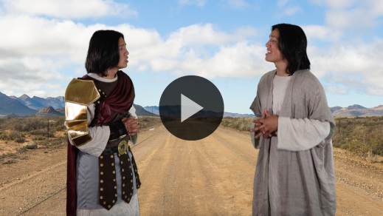

Bible Story
A Roman Officer Shows Impressive Faith
Have you ever been in a situation like Dash when you needed something to happen that seemed impossible? (Group response) Sometimes we have a huge need, and we have no idea what to do. In those times, let’s remember that God can do the impossible. He knows what we really need and exactly when we need it. If something is God’s will for us, we can trust that He will make it happen. Let’s find out more about the Bible story Dash was talking about.
Teaching Time
At the beginning of our Bible story, Jesus was returning to Capernaum, a town where people had seen Him do miracles earlier in His ministry. What do you think the people in Capernaum might have thought about Jesus? (Allow responses.) Some people may have believed Jesus was the Messiah. Others probably doubted Him or didn’t like what He was teaching. But we know that Jesus was telling the truth! He was God’s Son, and He wanted everyone to believe in God.
Jesus was about to do something amazing—something that seemed impossible! It all started when a Roman officer came to Jesus for help. What do you think Roman soldiers like this man thought about Jesus? (Allow responses.)
Many Roman officials cared a lot about the empire of Rome. That was the government in charge over Israel. They didn’t like people who threatened their power, and some may have thought that Jesus might be that kind of person. But there was something different about the Roman officer in our Bible story. Let’s see how he lived out our Faith Fact. Let’s say it all together! I can believe for the impossible.
Grab your Bible or pull up a Bible app on your device. Turn to Matthew 8:5–13.
• In order to keep Large Group time moving along, we recommend that the leader reads the Scripture portions aloud.
• Optional: Remind the kids to mark this place with a bookmark, so they can read it on their own at home.
1. The Roman officer asked Jesus for help.
• Show the Teaching Point 1 Slide.
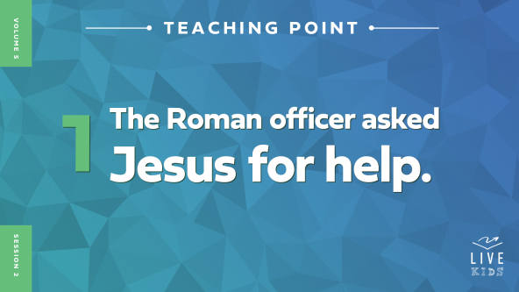
• Read Matthew 8:5–7.
When the Roman officer asked Jesus to heal his servant, Jesus answered right away. The servant was in a lot of pain and couldn’t move, and Jesus said He would go to the officer’s home and heal the servant. Seems pretty simple, right? But there was more happening than you might think.
Roman soldiers weren’t Jewish, which meant they weren’t waiting for the Messiah to come. But this officer had probably heard of Jesus and what He could do, and he believed it was true. That’s a miracle all by itself! Why do you think this officer believed in Jesus’ power? (Allow responses.) The Roman officer cared about his servant and didn’t want him to be in pain. So he asked Jesus for healing. Come on, that sounds impossible!
I need someone to come up and try to do an impossible flip with this water bottle and get it to land on its lid.
• Choose a volunteer.
• Hold up the water bottle.
Okay, who thinks our volunteer can flip the water bottle and get it to land on the lid? (Group response)
• Let the volunteer try to flip the water bottle onto the lid.
That was challenging, right? (Group response) Now imagine if someone asked you to heal a sick person—not just give them a bandage or help them feel better but actually heal them! That’s way harder than making a trick shot. Could you heal someone? (Group response) Of course not! Only God has the power to heal people. And because Jesus was God’s Son, He had that power too. Let’s see what happened next because of Jesus’ power and the Roman officer’s faith.
2. The Roman officer believed Jesus could do the impossible.
• Show the Teaching Point 2 Slide.
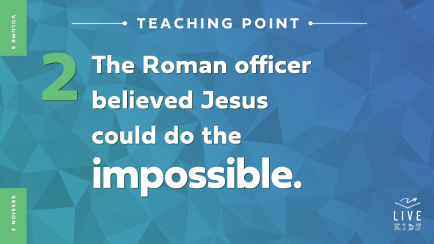
• Read Matthew 8:8–9.
Jesus offered to go to the Roman officer’s house to heal his servant. That would’ve been cool to see, right? But the Roman officer had so much faith, he knew Jesus could heal the servant from a distance just by using His words. That’s a lot of faith!
It would be like saying we trust that someone is so good at flipping water bottles that they can throw one backwards and still make it land on the lid. Anyone want to try that?
• Give one or more kids a chance to try it.
It might seem like the soldier was making it harder for Jesus to do the miracle. But is Jesus’ power limited by things like distance? (Allow responses.) No, it isn’t. The Roman officer understood how authority, or being in charge, works. He obeyed the commanders in authority over him, and the soldiers under his authority obeyed him. The officer realized that Jesus was in charge of everything because He was the Son of God. So he understood that Jesus didn’t have to get closer to the servant for him to be healed. Jesus just had to say the words, and healing would happen.
Think about this: The Bible tells us the same thing happened when God created the universe. God simply spoke, and everything was made! It’s amazing that the Roman soldier was able to believe that Jesus’ words had that kind of power, too. Let’s find out what Jesus said about the soldier’s faith.
3. Jesus honored the Roman officer’s faith.
• Show the Teaching Point 3 Slide.
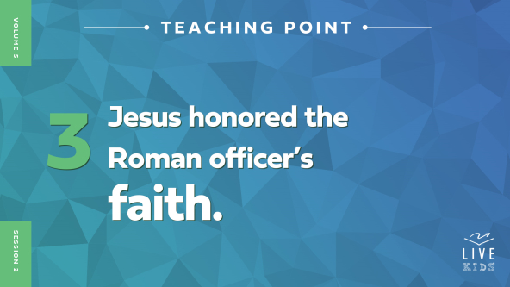
• Read Matthew 8:10–13.
Jesus was amazed by the Roman officer’s faith. In fact, Jesus said He’d never seen faith like it in all of Israel. That’s a big deal! The Roman officer wasn’t Jewish—God’s special people that He used in special ways. But that didn’t matter. Jesus said lots of people like the officer would be in heaven one day because of their faith.
And then Jesus did exactly what the Roman soldier believed He could do: He healed the servant just with His words! Jesus said the servant was healed because of the soldier’s faith. How do you think the soldier felt when he heard that? (Allow responses.)
So, what have we learned about believing for impossible things? First, Jesus is in charge of everything. Second, Jesus can respond to our faith with His power to do impossible things.
You might be wondering, “What if I have faith that Jesus can do something, but He doesn’t do it?” That’s a really important question. Here’s what we need to remember: God can do anything. And God loves us. If we ask and believe for a miracle and it doesn’t happen, it doesn’t mean God doesn’t have enough power or doesn’t love us. It just means He knows what we really need and exactly when we need it. He knows what is best, and He always wants us to ask Him when we need help.
Sometimes God wows us with a miracle, and other times He helps us through sad or difficult times. Our job is to ask for help and believe God can do anything—big or small, unusual or ordinary. Remember our Faith Fact? Say it with me. (Group response) I can believe for the impossible.

Prayer and Response
Consider playing a worship song softly in the background while kids pray.
We can have faith like the Roman officer by believing God is in charge of everything. When God simply speaks, the impossible can happen. We’re about to pray, but first I want to ask you one question: Do you really believe God can do impossible things?
It’s okay if you aren’t sure. Or maybe your answer is no. We’re going to pray that God would make our faith bigger, so we can believe in His unlimited power. One way to grow your faith in God is to pray about an impossible situation and ask for His help. The more we ask for God’s help, the more we notice He is helping us. And we need God’s help all the time!
As we pray today, let’s each choose a situation that seems impossible. Let’s ask God to help people who are hurting and make things work out the way they should. We’ll try our best to believe that God knows what’s needed and trust Him. We’ll pray on our own for a few minutes, and then we’ll pray together.
• Give kids a few minutes to pray about their situation.
Prayer
Optional: Have the kids repeat phrases of the prayer after you.
Dear God, thank You for Your power. You have the ability to change anything. Please help me trust You more and more. Help me believe You can do things that seem impossible. In Jesus’ name. Amen.
Faith Verse
Our Faith Verse is about being bold and courageous. It’s a great reminder as we believe for God to do impossible things. Let say it together and do the actions.
• Play Faith Verse Video.

1 Corinthians 16:13–14 (NLT)
Be on guard. Stand firm in the faith. Be courageous. Be strong. And do everything with love.
Let’s say it one more time, all together. (Group response) Great work!
Faith Fact
Before we move on, let’s review our Faith Fact. I can believe for the impossible.
• Show the Faith Fact Slide.
Let’s say the Faith Fact together. (Group response) I can believe for the impossible. Now place your hand over your heart. And let’s say it again. I can believe for the impossible.
• Dismiss kids to Small Group time or to go home if your group time ends here.

Small Group
30 Minutes
This section can be done in conjunction with the large group or on its own if you do small groups with your kids. During Small Group time, the goal is to connect the kids with the Word of God and to each other. All activities are led by the small group leader.

Group Connection
Anything Is Possible
You Will Need
- Ball

No prep is needed for this activity
In our Bible story, we heard about a Roman officer who wasn’t afraid to ask Jesus for something that seemed impossible. Jesus honored the officer’s faith and healed his servant without being with him! It’s important to trust that God can do anything, even what seems impossible. Our faith gets stronger as we believe boldly and see God’s power.
Let’s talk about that. When you get the ball, you’re going to answer this question: “What would you ask for if you knew it would happen?” I’ll go first.
• Share your response. Then pass the ball to the person next to you or toss it to someone in the group.
• Repeat until each kid has a chance to respond.
The Roman officer believed for something that seemed impossible, but Jesus honored his faith and made a miracle happen for his servant. This is a great reminder that with God, all things are possible. We can believe in God’s power and trust Him to do what’s best.

Bible Lesson Recap
• If small group activities are not immediately following large group time, you may want to read the Bible story passage before the discussion.
You Will Need
- Bibles for kids in the group to share
No prep needed for this activity.
Bible Story Review: A Roman Officer Shows Impressive Faith Matthew 8:5–13
What was the most interesting part of today’s Bible story? (Allow responses.) Those are great answers! A Roman officer asked Jesus to heal one of his servants. Jesus offered to come to the officer’s house, but the officer said all Jesus needed to do was speak the words and it would be done. Jesus was amazed by the officer’s faith and healed his servant.
• Give each kid a Bible and read the Bible story together.

Group Discussion
Feel free to use all or just a few questions as a jumping-off place for good discussion. Questions marked with * are designed for more conversation. Adjust the questions based on the age or maturity of your group. Typically, older kids will be able to dive a little deeper than younger ones.
Questions
Why was it a big deal for the Roman officer to ask for Jesus’ help?
* What do you think Jesus’ followers were thinking while He was talking with the Roman officer?
What did the officer say when Jesus offered to go heal the servant?
Why did the Roman officer trust Jesus so much?
Why was Jesus so impressed with the Roman officer’s faith?
* What kinds of impossible things can we believe God for?
* Have you ever seen God do something impossible? What happened?
* Would you feel bold asking God for something that seemed impossible? What would that kind of boldness look like for you?
* How would your life be different if you believed for impossible things to happen in God’s timing?

Live It
Faith Fact
Our Faith Fact today is I can believe for the impossible. The Roman officer showed us what happens when we believe boldly in God’s power. When we have faith God can do impossible things, we trust Him and our faith keeps growing as He shows His power. We can even have faith for others’ needs, which is exactly what the Roman officer did. When we pray for someone, we’re asking God to do the impossible in their life—right where they are.
Challenge
This week’s challenge is to notice someone who is going through a difficult time and needs prayer. Maybe you have a sick relative or a friend who needs a new family car. Whatever the need is, ask the person if you can pray with them about it. Believe that God can do the impossible and see how God answers your prayer. He might even use your faith to show the other person how to believe for impossible things.
Prayer
Finish group discussion by sharing prayer requests and praise reports. Keep track of your small group’s prayer requests and review them each time you meet.
• Have kids share needs and pray with boldness for each other’s prayer requests.
Dear God, thank You for hearing us when we pray. Please help us to be bold when we bring our needs to You. Help us to trust that You will help us in the right way at just the right time. In Jesus’ name, Amen.

Faith Verse Review
You Will Need
- Small Group Faith Verse Review, one per team
- Scissors
Getting Ready
- Print copies of the Small Group Faith Verse Review, one per team.
- Cut apart the words of the Faith Verse for each team.

Our Faith Verse is 1 Corinthians 16:13–14. God wants us to do everything in love, becoming strong, brave, and bold in our faith. Let’s go over the verse together.
• Show Faith Verse Video.
1 Corinthians 16:13–14 (NLT)
Be on guard. Stand firm in the faith. Be courageous. Be strong. And do everything with love.
When we believe boldly, we are courageous in our prayers. We aren’t afraid to bring our needs to God. Let’s review our Faith Verse as a group a couple of more times. Try to learn it as best as you can because you will need to know it for the Faith Verse game.
• Say the verse as a group a couple of times.
Faith Verse Fun
Unscramble It!
Now it’s time to put our knowledge of the Faith Verse to the test. Your goal is to unscramble the Faith Verse words as fast as you can and lay them out in the proper order. Let’s see who can do it the fastest.
• Have kids form even teams.
• Give a set of Faith Verse slips to each team.
• Play the game.
Great job, everyone! Memorizing this Faith Verse will help you be bold in your faith.

Activity Page
Maze Challenge
You Will Need
- Small Group Activity Page, one per kid
- Small Group Activity Page Answer Page
- Pencils or pens, one per kid
Getting Ready
- Print copies of the Small Group Activity Page, one per kid.
- If needed, print a copy of the Small Group Activity Page Answer Page.
Our Faith Fact is I can believe for the impossible.
• Hand out a copy of the Small Group Activity Page and a pencil to each kid.
Let’s navigate this maze to get the Roman officer to Jesus. Sometimes it can feel impossible to get through what’s happening. But with focus, determination, and God’s help, we can navigate the mazes in our life.

Dismissal
Remember, we can boldly ask God for what we need. And we can believe in His power to do the impossible. God’s Word is our foundation. It gives us courage and shows us that God can do anything!
Prayer
Dear God, please help us to believe that You truly have power over everything. We want to trust You more and more. Continue to grow our faith, so we can tell others about Your power and show them Your love. In Jesus’ name. Amen.
Faith Fact Recap
• Show the Faith Fact Slide.
Remember that God doesn’t just want me or someone else to believe that He can do what seems impossible. He wants you to believe it too! Let’s say our Faith Fact one more time together. I can believe for the impossible. I’m so glad you were here today. I can’t wait to see you next time.
• Send home the Small Group Activity Page.
• Remind parents that there are Family Devotions available on the app to do with their kid.
• Tell everyone the date and time for the next session.

